**EXPERIMENT 12**

**CREATION OF VIEWS AND ASSERTIONS**

1. create table bank_exp12(bankcode varchar(3) primary key, bankname varchar(50) not null, headoffice varchar(20), branches int check(branches > 0));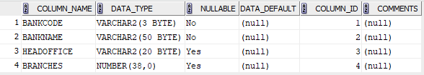

insert into bank_exp12 values('SBT','State Bank of Travancor','TVM',10);

insert into bank_exp12 values('SBI','State Bank of INDIA','KVLD',15);

insert into bank_exp12 values('UBI','Union Bank of India','ERNAKULAM',15);

select * from bank_exp12;

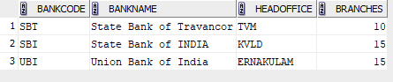

1. create table branch_exp_12(branchid varchar(6) primary key , branchname varchar(25) default 'NEW DELHI',bankid varchar(8), foreign key(bankid) references bank_exp12(bankcode) on delete cascade);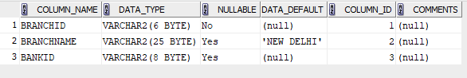

insert into branch_exp_12 values(1,'KOTTAYAM','SBI');

insert into branch_exp_12 values('2','IDUKKI','UBI');

insert into branch_exp_12 values('3','KASARGODU','SBT');

insert into branch_exp_12 values ('4', DEFAULT, 'SBT');

select * from branch_exp_12;

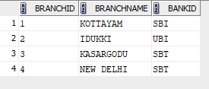

1. delete from bank_exp12 where bankcode='SBT';



select * from bank_exp12;

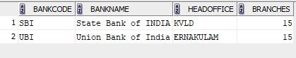

select * from branch_exp_12;

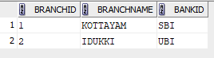

1. alter table branch_exp_12 drop primary key;



describe branch_exp_12;

|  |
| --- |
|  |

1. create view bank_headoffice as select * from bank_exp12 where headoffice='ERNAKULAM';

select * from bank_headoffice;



1. create view bank_branch as select * from branch_exp_12 where branchname='KOTTAYAM';

select * from bank_branch;

